**7BUIS030W REVISION -2**

Question 1

A firm appoints an agency to vet a potential candidate for a job. The firm gives the employment history and other details to the agency and based on that the agency conduct a background verification of 2 people. Based on the data protection act , describe who are the data actors in this scenario [6 Marks]

Question 2

A training centre provides the members of staff of a large organisation with training courses in a wide range of subjects and at different levels (e.g. beginner, intermediate, proficient, advanced). The training courses are organised over a number of full days(e.g. 2 days, 3 days, 5 days, etc.) The centre is seeking to design and develop a database-driven management system to be used internally to help organise the scheduling of the training courses. The Conceptual Entity-Relationship Diagram (ERD) for part of the training centre’s management system is shown below (figure 1). Carefully consider this conceptual ERD.

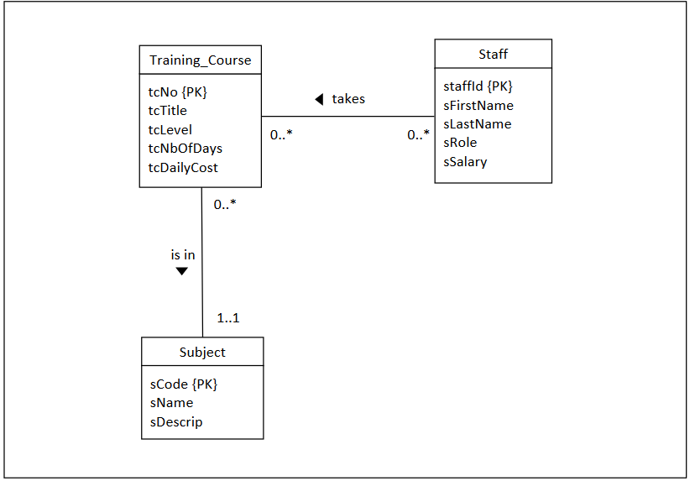

Figure 1: Conceptual ERD for part of the management system

Question 3

1. Discuss in detail the multiplicity of the relationship ‘is in’ (between the entities Training_Course and Subject). Provide adequate justifications to support your answers. [4 Marks]
2. Briefly explain how you would map the relationship ‘is in’ (between the entities Training_Course and Subject) to a logical ERD. Provide a diagram to support your answer. Make sure you include all the correct attributes and keys. [6 Marks]

(a)Discuss in detail the multiplicity of the relationship ‘takes’ (between the entities Staff and Training_Course). Provide adequate justifications to support your answers. [4 Marks]

(b)Briefly explain how you would map the relationship ‘takes’ (between the entities Staff and Training_Course) to a logical ERD. Provide a diagram to support your answer. Make sure you include all the correct attributes and keys. [6 Marks]

Question 3

(a)Write a SQL query to display the titles, durations and daily costs of courses at beginner level and courses at intermediate level, but only for those courses that cost more than £250.00 daily. [5 Marks]

(b)Write a SQL query to display all the tables in the rectified logical ERD of the above conceptual ERD. Make sure your correctly identify the data types of all the attributes in the tables.

[8 Marks]